**Online Jewel shop**

**About:**

Online jewel shop is about an online jewels sales platform. Here we can purchase the product from multiple shops by comparing the price, making charges and design etc. here the users can have more advantage of comparing the same product with multiple shop and much more.

**TYPES OF USERS:**

1. Jewel shops
2. Customer
3. Admin (Application )

**FUNCTIONALITIES / PROCESS:**

**Jewel shops process:**

* Signup/ Registration
  + Jewel shop need to register with details of shop, Email, phone number, licence and address with branches.
* Product /Category of jewel shop
  + Profile of the shop, what types of material (gold, silver, platinum, diamond etc.,)
  + Type of jewels (ring, chain, necklace, ear ring. Related to the material what the shop has selling
* Offers
  + Jewel shop specific offers while in festival times and opening time as per their need.
  + Saving plan and the benefits for the customer
  + Annual discount for regular customer
  + According to the Payment: the offers will given
* Quires/review
  + Replay to customer quires and reviews

**Customer process:**

* Signup/ Registration
  + Customer need to register with details of Email, phone number, and address.
* Searching
  + Searching jewel with different shops and different rating (by type of material, karat, model, etc.)
  + Gold Savings account details
* Payment
  + UPI payment / card payment

**Admin process:**

* Registration approvals
  + Verify the details and approving the jewels shop.
  + Verify the customer details and approve
* Subscription
  + Annual subscription for the customer with specific offers

**INPUT AND ACTIONS:**

**Jewel shops process:**

* **Sign up/ Registration:**
  + Name /username
  + Email id
  + Address for communication
  + Phone number
  + Licence of the shop
  + GST/TIN number
  + Number of branches
  + Type of shop(like gold, silver)
  + Social media link (facebook, instagram etc.)
  + Description about the shop

**Actions for Signup/ Registration**

* + - User name validation
    - Email id verifications
    - Phone number verification
    - Licence validation (upload documents)
    - GST / TIN validation
    - Display the social medial link
    - Submit
* **Product /Category of jewel shop (add/update/delete)**
  + Product id
  + Product type
  + Making charges
  + Category (gold, silver, platinum)
  + Product price
  + Product description
  + Add button
  + Update button
  + Delete button

**Action for product / category**

* add product id
* select the category and type of product using select box
* making charges of the product
* addition information about the product
* product price with offer and making charges
* add button/update button /delete button
* **Offers**
  + Festival offers
  + Shop offers

**Actions for offers**

* Posting festival offers push message to the customer
* Posting festival offer in the shop pages according to festival times
* **Quires / Review** 
  + Customer quires
  + Customer review for the purchased product

**Action for Quires / Review**

* Customer quires in separate page
* Customer review in separate page

**Customer process:**

* **Sign up/ Registration:**
  + Name /username
  + Email id
  + Address for communication
  + Phone number
  + Aadhaar Number / PAN number

**Actions for Signup/ Registration**

* + - User name validation
    - Email id verifications
    - Phone number verification with OTP
    - Aadhaar number
    - PAN number
    - Submit
* **Searching**
  + Search the product in product page
  + Search the saving account in account page

**Actions for searching**

* Search the product by gold, silver etc. and search by product(ring chain etc.),cost and rating from all the shops, if product is not there show no result
* Search the account details if not show no active account
* **Payment**
* Payment by UPI
* Pay by online banking

**Actions for payment:**

* UPI payment need to use
* Banking details need to provide

**Admin process:**

* Registration approvals
* Approve the shop by verifying the details and remove if need
* Verify the customer details approve and delete if need
* Provide subscription detail and provide offer for the subscribed customer

**Actions for Admin:**

* Shop in separate page filter approved and unapproved shop to approve
* Customer list in page with filters (normal customer and premium customer)
* Offer need to provide for subscribed customer

**Database design:**

**Jewel shops:**

* **Tabel_Registration**
  + Name
  + Username
  + Email
  + Address_shop
  + Phone_no
  + Shop_branches
  + Licence_detail
  + GST_NO
  + Tin_no
  + Shop_Types
  + Shop_description
* **Tabel_product**
  + product_id
  + produt_type
  + product_making_charges
  + product_price
  + product_description
  + product_offers
* **Tabel_account**
  + Acc_id
  + Acc_holder_name
  + Acc_type
  + Acc_plan
* **Tabel_Offers**
  + Festival list and its offers
  + Shop offers (regular)
* **Tabel Quires**
  + Q_person_Name
  + Q_person_ID
  + Q_person_email
  + Q_pesron_quires
* Tabel Review
  + R_person_name
  + R_perosn_ID
  + R_person_email
  + R_person_quires

**Customer:**

* **Tabel_Registration_customer**
  + Cust_id
  + Cust_user_name
  + Cust_name
  + Cust_email
  + Cust_phone_no
  + Cust_aadhaar_no
* Customer_payment
  + Pay_id
  + UPI_details
  + Card_details

**Admin:**

* **Tabel_subscription**
  + Sub_id
  + Sub_Validity
  + Offer_description
  + Offer_validity

UI Pages:

Home Page

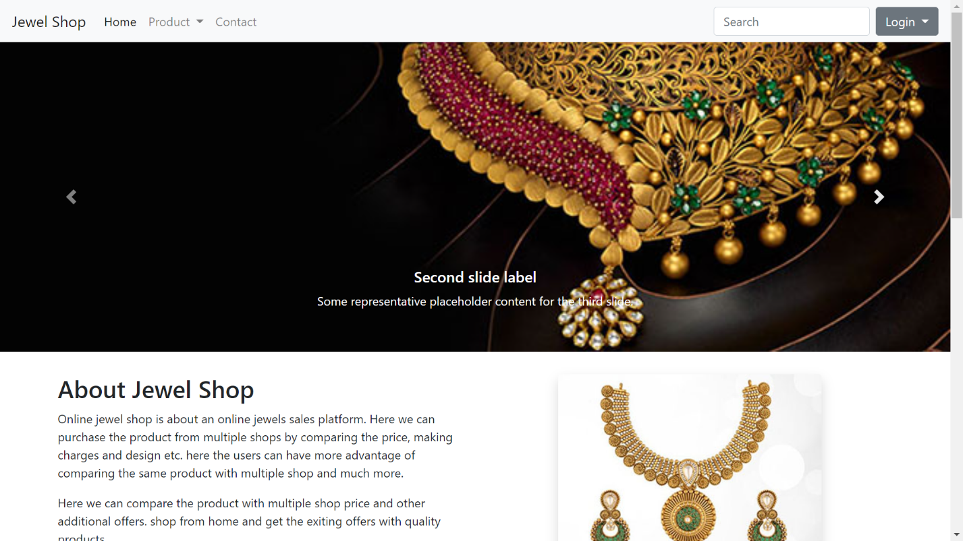

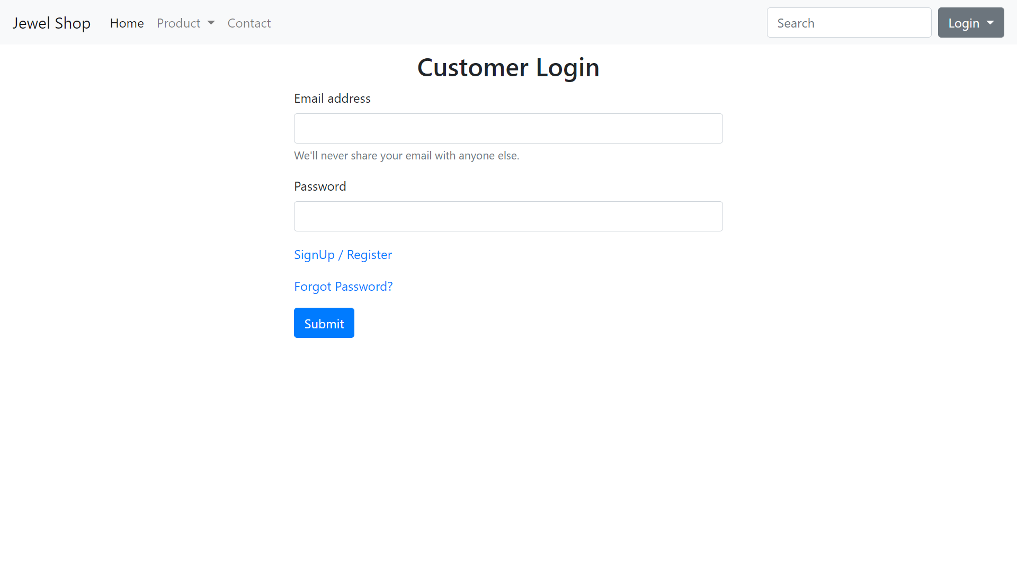Customer Login page

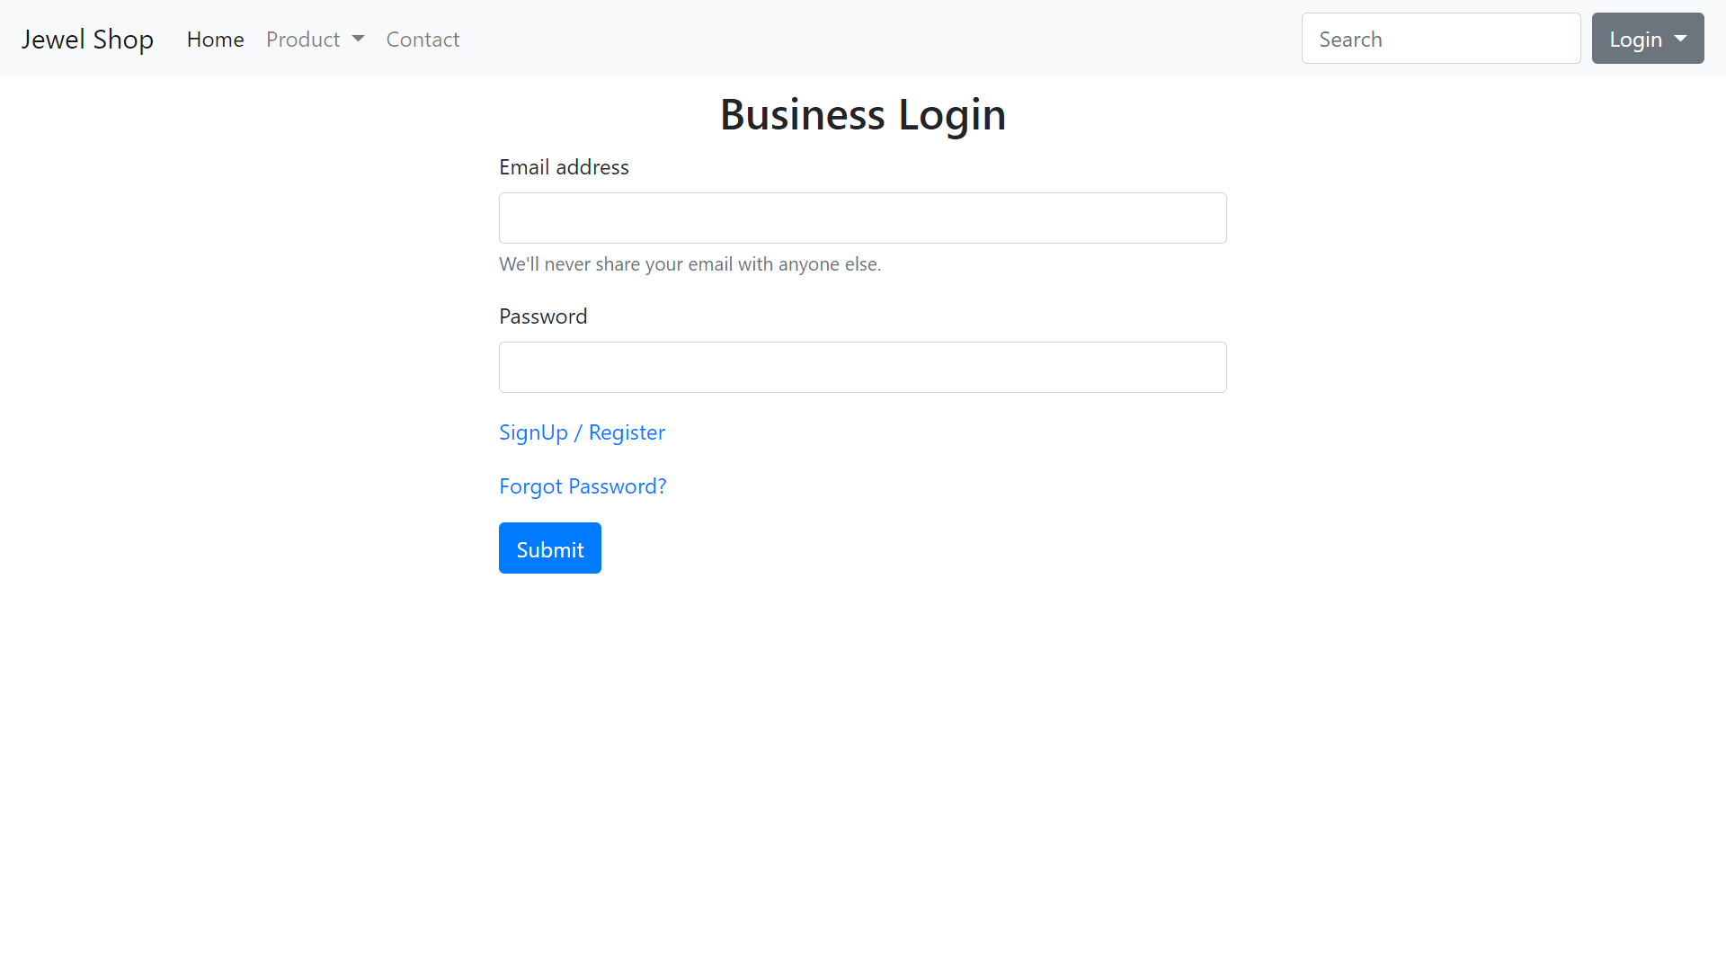Business Login:

Reset Password Page:

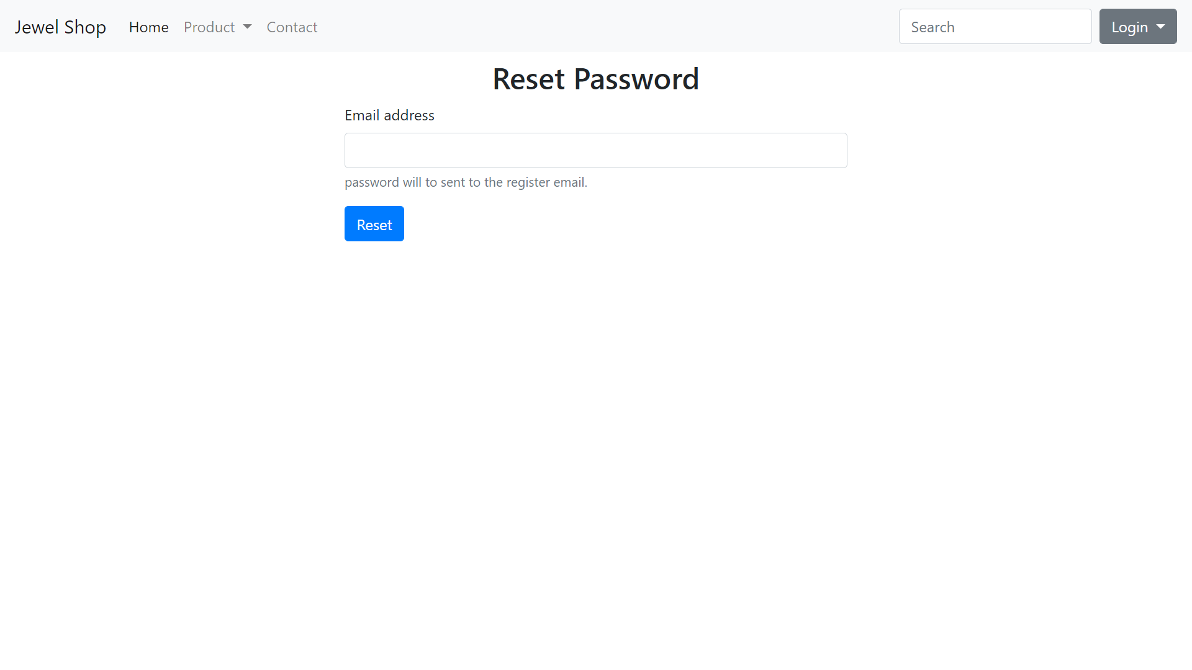

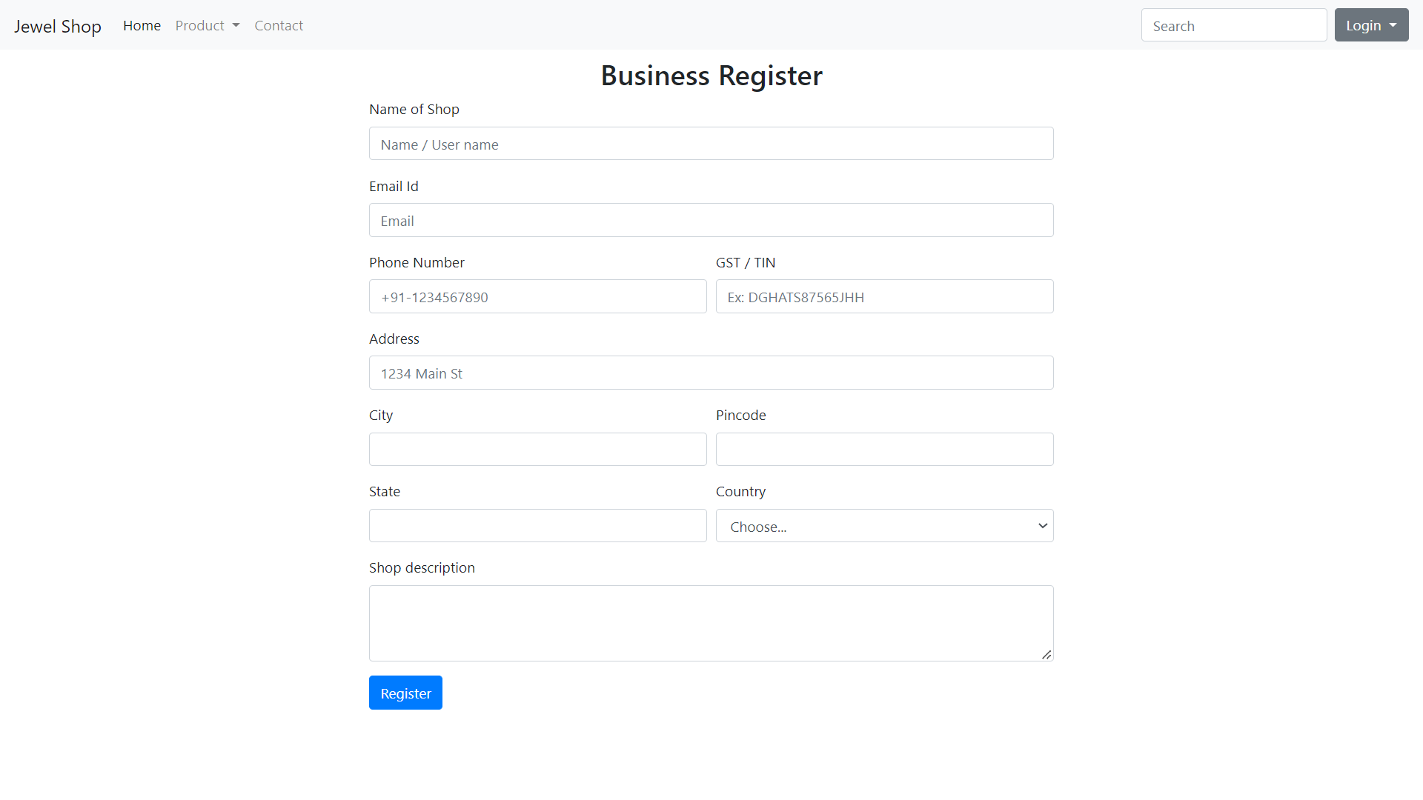Business Register:

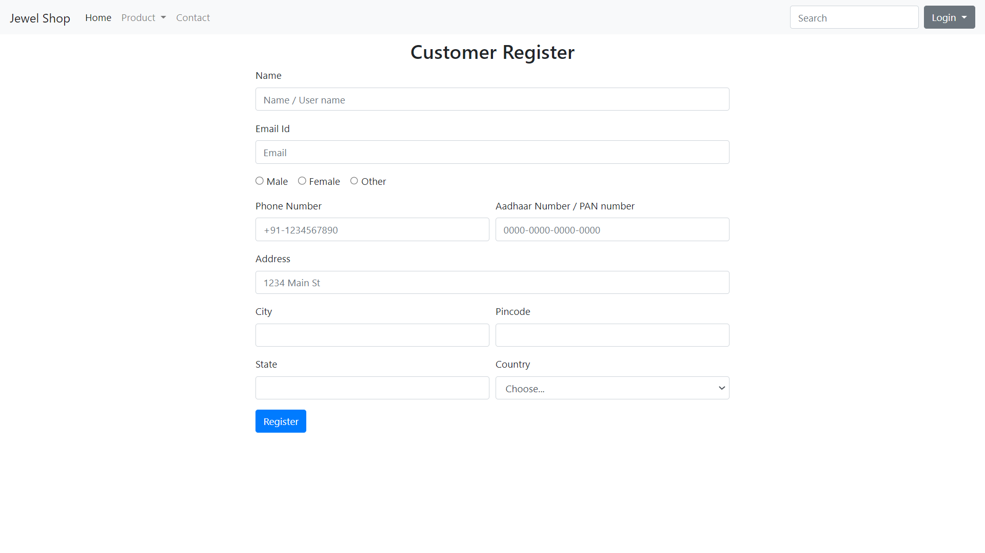Customer Register:

Product adding by business:

